Surface Tension and Viscosity of the Ni-based Superalloys

LEK94 and CMSX-10

Measured by the Oscillating Drop Method
on Board a Parabolic Flight

R. K. Wunderlich and H.-J. Fecht
University of Ulm, Institute for Micro and Nanomaterials,
Albert-Einstein-Alle 47, D-89081 Ulm

G. Lohöfer
Institut für Materialwissenschaft unter Weltraumbedingungen
Deutsches Zentrum Luft- und Raumfahrt, Linder Höhe, Köln

Abstract

The surface tension and the viscosity of the Ni-based superallloys LEK94 and CMSX-10 were measured by the oscillating drop method in a containerless electromagnetic processing device on board a parabolic flight. Surface oscillations were recorded by 150 and 200 Hz frame rate digital cameras positioned in two perpendicular directions and by the inductive coupling between the oscillating sample and the oscillating circuit of the radio-frequency heating and positioning generator. The surface tensions as a function of temperature of LEK94 and CMSX-10 were obtained as σ(T) = 1.72 − 4.20 × 10⁻⁴ (T – 1656 K ) Nm⁻¹ and σ(T) = 1.71 − 4.23 × 10⁻⁴ (T – 1683 K) Nm⁻¹, respectively, the viscosities at the liquidus temperatures were obtained as 9.8 and 7.8 mPa.s respectively

- Introduction
Ni-based superalloys are important high temperature materials with the main application for energy generation in land based turbines and in the high pressure section of jet engine turbines. Ni-based superalloys are based on the intermetallic Ni₃Al phase with additions of further transition metals like Ti, Cr, Co, refractory elements like W, Mo, Ta and elements of the Pt-group like Re which is applied in the second and third generation Ni-based superalloys. They represent complex alloys with often more than eight components. The typical Ni-concentration is between 56 and 68 atomic percent (at%), Al between 8 and 16 at% Al, refractories between 3 - 8 at% and Re in the range 1 – 3 at%. One goal of current alloy development is an increase in the working temperature combined with high fatigue and creep resistance.
The main production route is casting of turbine blades with directional or seeded single crystalline solidification followed by extensive heat treatment in the solid phase,,. Optimization of production technology and of cast product quality requires knowledge of thermophysical property values in the liquid and high temperature solid phase which are used as input parameters in a large variety of casting simulations,. Important thermophysical properties for a first order casting simulation are solidus and liquidus temperature, fraction solid-liquid, specific heat capacity, density, thermal conductivity, viscosity and surface tension. The surface tension and viscosity are required for the modelling of fluid flows like surface and gravity driven flows. Other important issues are form filling in near net shape castings, and the prediction of defects such as bubble formation.
The measurement of these properties in the liquid phase at high temperature with conventional thermoanalytic equipment is often complicated and fraught with error due to the presence of chemical or dissolution reactions between the liquid metallic alloy and a container. The various thermophysical properties are affected to a different extent depending on alloy composition, container material and alloy composition. An alternative measurement approach which has been increasingly applied in recent years for thermophysical property measurement in the liquid phase is containerless processing using electromagnetic and electrostatic levitation.

- Experimental Elements
Experimental set up and processing. The experiments were performed in a radio frequency (rf) electromagnetic levitation device on board parabolic flights. Details of the set up and data evaluation are described elsewhere,. In short: Metallic specimen are positioned in the center of two induction coils a dipole coil for heating a quadrupole coil for positioning. The coils are part of two independent radio frequency (rf)-oscillating circuits one for heating and positioning operating at two different frequencies. The dipole field is used for heating and the quadrupole field for positioning. The whole set up is contained in a high vacuum compatible chamber equipped with feedthroughs for the rf- power supply, observation windows for temperature measurement and optical observation, and a gas flow unit with gas purification cartridges giving a nominal purity of the process gas atmosphere < 1 ppm O₂ and H₂O. The process chamber is connected to a sample chamber holding up to 8 samples on a rotation stage. Samples are contained in a sample holder with an open cage on top which can be moved into the center of the rf-heating and positioning coils by a transport mechanism. The sample temperature is measured by an optical pyrometer positioned in the direction of the axis of the dipole heating coil. The sample shape is recorded by two digital cameras one in the axial position and one in the perpendicular radial position with frame rates of 150 and 200 Hz, respectively. Processing is performed under an inert gas atmosphere of Ar or He, before processing the chamber is evacuated to a pressure < 1×10⁻⁶ mbar.
Parabolic flights provide about 20 sec of reduced gravity. This time is sufficient to heat, melt, heat in the liquid phase and cool a sample to solidification after the heating field is turned off or reduced to some minimum value. During the nearly force free cooling phase pulses of the rf-heating field are applied for the excitation of surface oscillations. Care was taken to apply relatively small pulse amplitudes to avoid a large sample deformation which will result in non-linear effects in the fluid flow which will affect the evaluation of the viscosity from the measured damping time constant of the surface oscillations.
A typical temperature time profile of processing a LEK94 specimen in one parabola is shown in Figure 1 exhibiting heating in the solid phase, melting, heating in the liquid phase and cooling to solidification. After a preset maximum temperature was reached the rf-heater voltage was reduced to a minimum value to allow a nearly force free cooling of the specimen. During the cooling phase two pulses of the rf-heater are applied to excite surface oscillations. The large temperature variations observed during heating in the solid phase originate from sample movement caused by microgravity disturbances. Both samples exhibited an underooling of ΔT_{u} = 90 ± 20K in all parabolas indicating the cleanness of the specimen.

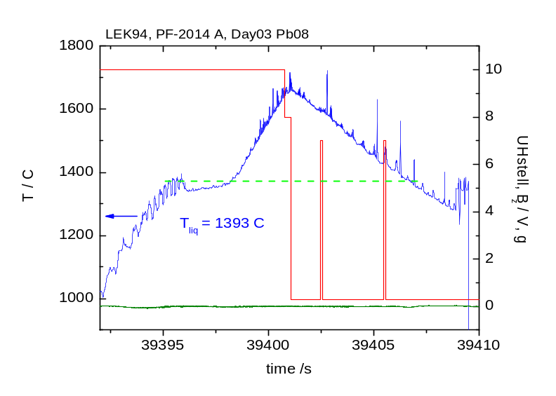
Fig.1: Temperature-time profile of a LEK94 specimen during one parabola.Temperature is shown on the left hand ordinate, indicated by an arrow. The heater control voltage, and the microgravity level are shown on the right hand ordinate. The dashed horizontal line indicates the liquidus temperature.

In addition to the optical recording, surface oscillations of the liquid test specimen could also be evaluated from a recording of the rf-heating generator oscillating circuit current, frequency and in principle from the phase shift between heater oscillating current and voltage. The mutual induction between the current distribution in the sample and the current in the rf-heating coil induces a current in the rf-heater oscillating circuit which is modulated with the surface oscillations of the specimen. An electronic device termed sample coupling electronics (SCE) was intergrated in the rf-heating generator oscillating circuit, to extract these signals from the rf-heating generator oscillating circuit. The sampling rate was 400 Hz and the sensitivity better10⁻³. The primary purpose of this device was the measurement of the electrical resistivity in the liquid phase.
Sample materials. The composition of the sample materials used in the experiments is given in Table 1. The composition of CMSX-10 was taken from Erikson, the composition of LEK94 from Glatzel et al.. The LEK94 material was provided by an industrial partner,

Tab. 1: Composition of LEK94 and CMSX-10 alloys used in the experiments in at%
Element | Cr | Co | Mo | W | Ta | Re | Al | Ti | Hf | Ni
LEK94 | 6.8 | 7.4 | 1.4 | 1.4 | 0.9 | 0.9 | 15.2 | 1.2 | 0.07 | bal
CMSX-10 | 2.4 | 3.2 | 0.26 | 1.7 | 2.8 | 2.0 | 14.2 | 0.26 | 0.11 | bal

CMSX-10 was fabricated by alloying elemental materials in an arc melter. As the alloy was intended for processing on the liquid phase no dedicated effort for solution heat treatment was made. Lower melting point eutectic or near eutectic compositions between the lower and high melting point elements were first made to assure complete dissolution of the refractory elements. Proper weight cut pieces of the pre alloys were then further alloyed with Al and Ni to obtain the final alloy. Ingots were cast into 5 mm diameter rods in a water cooled copper mould. Slices were cut from different locations on the rod for SEM and EDX analysis to assure homogeneity of the as cast material and complete dissolution of the refractory elements.
Spherical samples of 6.5. mm diameter for processing in the parabolic flight eml were cast by suction casting of proper weight cut pieces in a water cooled copper mould in an arc melter. After casting runners and feeders were cut off with a diamond cutting blade. Samples were grinded to a mirror finish under flowing water, cleaned in an ultrasonic bath with acetone and degassed for about 2 hr at T = 120 °C in high vacuum. The average sample diameter was 6.5 mm. The samples were weighted on a precision scale to an accuracy better 0.1%. Samples were stored and packed in a glove box under high purity Ar.
Oxygen analysis with the LECO hot gas extraction method was performed in a certified laboratory on samples produced in the same series as the samples to be tested in the parabolic flight. For both alloys an oxygen concentration of < 10 wt ppm was obtained. Similar analysis was performed on the parabolic flight processed specimen giving an oxygen concentration < 20 ppm for both specimen.

3. Thermal analysis
Thermal analysis. Analysis of the experimental data requires knowledge of the temperature in the liquid phase which in turn requires a proper emissivity setting of the pyrometer used for non-contact temperature measurement. The pyrometer emissivity setting was fixed by comparison of the liquidus temperature obtained from the temperature-time profile with the liquidus temperature obtained from calorimetric measurements. For the determination of the solidus and liquidus temperatures calorimetric measurements were performed with a high temperature calorimeter. Different heating were applied to allow for an extrapolation to heating rate zero to account for the instrument specific thermal relaxation time. Results are given in Table 2.
The evaluation of the viscosity from the damping time constant of the surface oscillation requires knowledge of the sample radius and mass. The mass is known from precision weighting of the experiment samples. The sample radius of an ideal spherical sample at room temperature (RT) was determined from the mass and the density. The density at RT was evaluated by the pycnometer method. Results are listed in Table 2. For CMSX-10 the measured density at RT agrees very well with a value of ρ(RT) = 9.05 g cm⁻³ given in the literature. Scaling of the sample radius from RT to the solidus temperature was performed by a dilatometer measurement. Results of the relative length change, ΔL/L_{o}, between RT and T_{sol} are given in Table 2. The change of the sample radius on melting was evaluated from an assumed volume change of +2.5% on melting. This number is in accord with density data in the liquid phase of various Ni-based superalloys. As a result, a change of the sample radius between RT and T_{liq} of + 5.05 % and +5.19 % was obtained for LEK94 and CMSX-10, respectively. The density of CMSX-10 in the liquid phase was measured by electromagnetic levitation by Mills et al.. At the liquidus temperature a value of ρ(T_{liq}) = 8.081 g cm⁻³ was obtained which agrees very well with a value of ρ(T_{liq}) = 8.041 g cm⁻³ obtained from the scaling applied here.

Tab. 2: Solidus and liquidus temperatures, ρ_{RT}: density at room temperature, ΔL/L_{o}: relative linear
length change between RT and T_{sol} , m_{S}: sample mass used in the parabolic flight experiments.
 | T_{sol} / K | T_{liq} / K | ρ_{RT} / g cm⁻³ | ΔL/L_{o} | m_{S} / g
LEK94 | 1607 ± 4 | 1656 ± 4 | 8.33 | + 2.55 × 10⁻² | 1.197
CMSX-10 | 1651 ± 4 | 1683 ± 4 | 9.02 | + 2.69 × 10⁻² | 1.201

In passing we would like to note that the liquidus temperatures of CMSX-4 and CMSX-10 given by Li⁵⁵ et al. differ from the ones given here by +6 and -7 K, respectively. The values given in this work were measured in our laboratory with a high temperature DTA and were corrected for heating rate dependent effects by extrapolating heating rate dependent measurements to zero heating rate. This discrepancies highlight the difficulty of obtaining exact liquidus temperatures of high melting point alloys with an absolute accuracy of < 2 K.

4. Data evaluation
The surface tension and the viscosity were measured by the oscillating drop method in an electromagnetic levitation device. The oscillations of a liquid sphere under 1-g and under reduced gravity conditions have been described in great detail by various authors,,,. In equilibrium or following pulse excitation the sample oscillates in the Y_{2m} modes after higher order modes have decayed. Y_{2m} represents the spherical harmonics of order 2 with m = 0, ±1, ±2. Under reduced gravity conditions the frequencies of the m = 0, ±1, ±2 are degenerate resulting in a single oscillation frequency, ν_{R}, which is easily related to the surface tension by Raleigh’s formula according to:
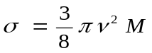
with M the mass of the sample. Under 1-g conditions and for a non spherical specimen the degeneracy of the different m modes is removed resulting in a five peaked oscillation spectrum. This is the case in ground based electromagnetic levitation requiring a levitation field with a strong gradient in the direction of the g-vector causing a deformation of the sample. The magnetic pressure on the sample surface causes a shift of the oscillation frequencies. This shift was calculated by Cummings and Blackburn. In this correction the magnetic pressure on the specimen was expressed in terms of the center of mass oscillation frequency allowing to develop a correction formula based on easy to measure quantities. The validity of the Cummings and Blackburn correction formula was verified by a comparison of surface tension values obtained by the oscillating drop method in an electromagnetic levitation device in ground based laboratory and under microgravity conditions,,. Under microgravity conditions the force on a sample results from the quadrupole positioning field though in comparison to the 1-g case much reduced. The sample exhibits center of mass oscillations which are easily measured and can be applied with the Cummings and Blackburn formula to correct the measured oscillation frequency for the effect of the residual magnetic field pressure according to:
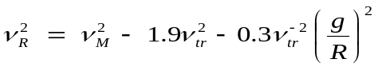
with ν_{M} the measured oscillation frequency, ν_{R} the undisturbed Raleigh frequency, ν_{tr} the center of mass oscillation frequency, g the gravitational constant and R the sample radius. With ν_{tr}(av) in the range of ν_{tr} = 2.6 ± 0.2 Hz this amounted to a -3.4 % correction of the measured ν_{M}² to obtain the ideal Raleigh frequency from which the surface tension was calculated.
The effects of sample rotation and precession on the oscillation spectra of under reduced gravity conditions were investigated in detail by Higuchi et al.,, showing that under microgravity conditions the single frequency oscillation spectrum is symmetrically split into two or more peaks. The symmetric splitting allows an unambiguous identification of the center oscillation frequency.
Under the assumption of laminar flow and a small excitation amplitude the viscosity, η, is obtained from the damping time constant of the surface oscillations, τ, as:
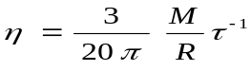
with R the radius of the sample. In the derivation of this formula the nonlinear term in the Navier-Stockes equation, i.e. the convective derivative was neglected. As such, care was taken to reduce the amplitude of the surface oscillation excitation amplitude to a minimum value which still allowed to analyze the surface oscillations. The precision of the determination of the damping time constant is estimated as ±10%.
The evaluation of surface oscillations from the digital image recordings has been described in detail elsewhere. The sample perimeter is obtained from an edge detection algorithm using a dedicated software tool. Different measures of the sample shape deformation are applied, such as the total projected area, the difference of the projected area with respect to the projected area of an ideal sphere of the same nominal diameter, the length of two perpendicular radii, their sum and difference. The default orientation of the analysis coordinate system axes was parallel and perpendicular to the dipole coil axis which corresponds to the symmetry of the Y₂₀ oscillation mode as seen with the radial camera. The orientation of the analysis coordinate system could be rotated including by a fixed angle or with a constant angular speed. This efforts were made to alleviate the effects of sample rotation and precession.
As an example Figure 2a shows the variation of the sample radius in the x-direction as a function of time together with the rf-heater control voltage showing two pulses for the excitation of surface oscillations. The radius variation shown in Figure 2a was extracted from the measured sample radius as a function of time by application of a high pass Fourier transform filter. Figure 2b shows the Fourier Transform (FFT) of the time slice indicated in Figure 2a from which the surface oscillation frequency was determined. Time intervals used for the FFT ranged from 0.3 to 0.6 s. With an average cooling rate of 60 K s⁻¹ each surface tension values represents an average over a temperature range of ± 8 to ± 14 K. The accuracy of the surface oscillation frequency as obtained from the Fourier transform is < 4%. Ideally the variation of the sample radius as a function of time should exhibit a purely exponential time dependence. The modulation of the radius signal originates from sample rotation and precession.
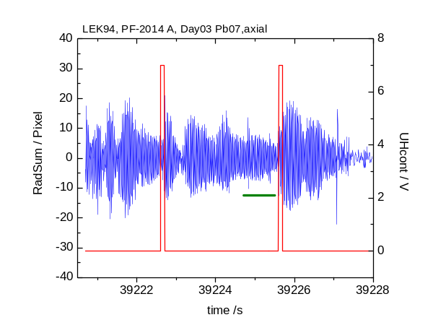
Fig2a.: LEK94 sample. Axial camera, 150 Hz recording, Variation of the sum of two perpendicular radii shown on the right hand ordinate; rf-heater control voltage shown on the left hand ordinate.
Horizontal bar indicates times slice used for the Fourier transformation shown in Fig. 2b.
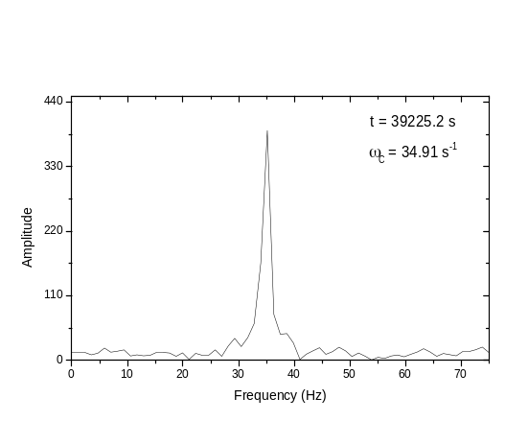
Fig2b.: Fourier transform of the radius sum variation in the time slice indicated in Figure 2a.

As an example of the application of the sample coupling electronics, the variation of the rf- heating oscillating circuit circuit, I_{H}(t), as a result of the sample surface oscillation is shown Figure 3a. The variation of I_{H}(t) originating from the changing sample resistivity as a function of temperature along the cooling curve occurs on a larger time scale than the surface oscillations and has been filtered out by a high pass filter similar to the analysis of the optical data. The surface oscillation spectrum obtained from a FFT of the time domain signal following the second excitation pulse is shown in Figure 3b. The 400 Hz data acquisition rate of the SCE results in a sharply peaked frequency spectrum. The full line represents a

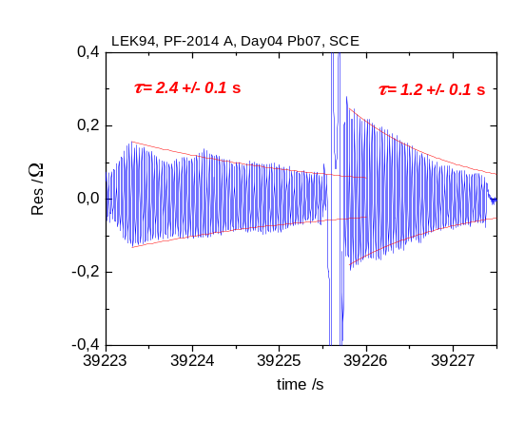
Fig3a.: LEK94. Variation of the rf-heater oscillating current obtained from the SCE.
The horizontal bar indicates the time used for the Fourier transform.

Lorentzian fit allowing the determination of the enter oscillation frequency with an accuracy < ± 0.5 Hz. It must be pointed out however, that in the presence of sample rotation or extensive movement, the SCE spectra exhibit several peaks with a concomitant reduction of the accuracy of the determination of the central oscillation frequency similar to the optical case.
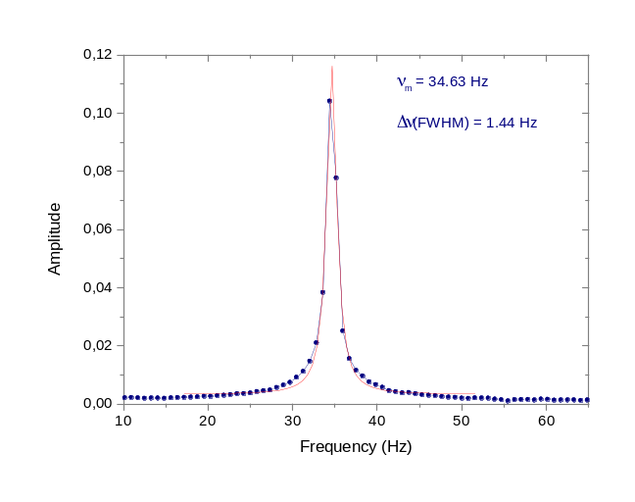
Fig3b.: LEK94. Fourier transform of the time signal following
the second excitation pulse as shown in Fig.3a.

The time domain signal following the second excitation pulse can be very well fitted with an exponential envelope from which the damping time constant can be evaluated. Instead of an exponential envelope the decay time constant can equally well be evaluated from a linear fit to a logarithmic plot of the squared resistivity variation. The same holds for the variation of the sample radius or other optical metrics of the sample shape variation.
In the absence of sample rotation the width of the Fourier transform of single peak is determined by the damping time constant and by the finite sampling interval. For the signal shown in Figure 3b the width at half maximum obtained from the Loretzian fit is Δν = 1.44 Hz. The finite sampling time of Δt_{s} = 1.6 s contributes Δν_{s} = 0.63 Hz to the observed spectral width resulting in a damping time contribution of Δν_{d} = 0.81 Hz corresponding to a damping time constant of Δt_{d} =1.23 s which agrees very well with the damping time constant from the exponential envelope and from the logarithmic fit. It must be pointed out however, that this good agreement between the damping time constants evaluated from the time domain and frequency domain signals is not the regular case. In many cases the time domain signal exhibits a modulation resulting in split or broadened oscillation spectra.

- Results
Surface tension. The surface tension of LEK94 as a function of temperature obtained from a single parabola is shown in Figure 4 with data evaluated from the optical recording of the sample shape oscillations and from the inductive coupling. On average the two data

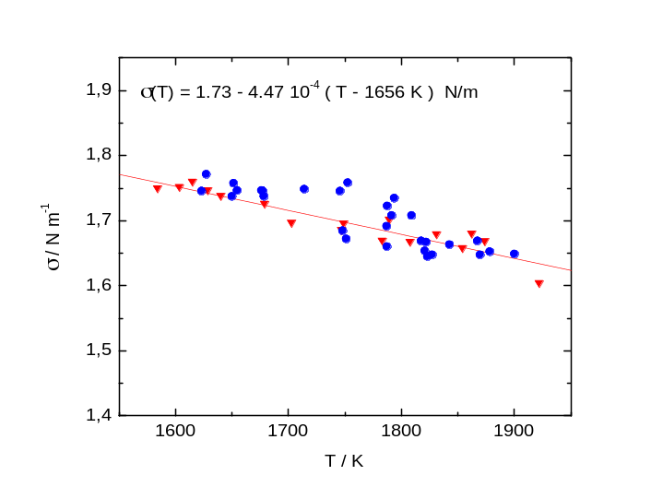
Fig.4: Surface tension of LEK94 as a function of temperature. Shown are values obtained
from a single parabola. (): values evaluated from optical recording ; (): values evaluated
from the sample coupling electronics. The full line is a linear fit to the SCE data.

sets agree to within ±2 per cent. The larger scatter of the optical data originated from sample movement in the rf-induction coil caused by disturbances in the micro-g quality. In Figure 5 similar data are shown for the CMSX-10 alloy. In both cases the surface tension as a function of temperature can be well represented by a linear dependence with a negative temperature coefficient. For the parabolas shown the surface tension as a function of temperature is represented by:
and
for LEK94 and CMSX-10, respectively. In Table 3 the average values of the surface tension at the liquidus temperature and of the temperature coefficient from all parabolas are given. For comparison the values of the Ni-based superalloy CMSX-4 obtained in previous work^{Higuchi CMSX-4} are also given.
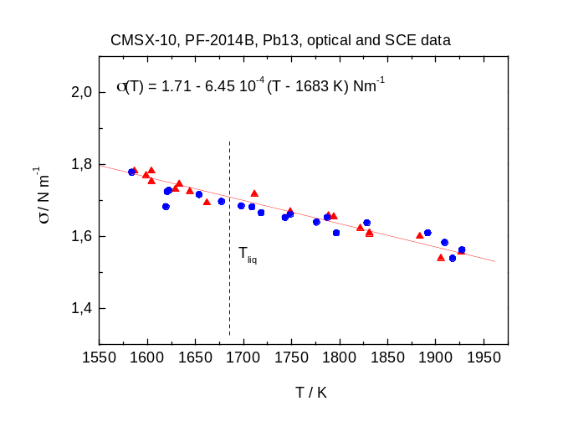
Fig.5: Surface tension of CMSX-10 as a function of temperature, values from a single parabola.
(): evaluated from optical recording ; (): evaluated from the sample coupling electronics.
The full line is a linear fit to the SCE data.

Tab.3: Surface tension, σ_{o}, at T_{liq} and temperature coefficient
dσ/dT of the alloys LEK94 and CMSX-10 and CMSX-4.
Alloy | σ_{o} / Nm⁻¹ | dσ/dT / Nm⁻¹K⁻¹
LEK94 | 1.72 ± 0.02 | - 4.51 × 10⁻⁴
CMSX-10 | 1.71 ± 0.02 | - 5.80 × 10⁻⁴
CMSX-4 | 1.79 ± 0.02 | - 9.09 × 10⁻⁴

Viscosity. In Figures 6a,b and 7a,b the viscosities of LEK94 and CMSX-10 are shown as a function of temperature and in the Arrhenius depiction, respectively. The scatter of the data originate from excessive sample movement caused by unsteady micro-g conditions. This conditions affects the evaluation of the damping time constant more than that of the surface tension because of the smaller time scale involved in the latter. The viscosity as a function of temperature can be reasonably well fitted by an exponential decay. For LEK94
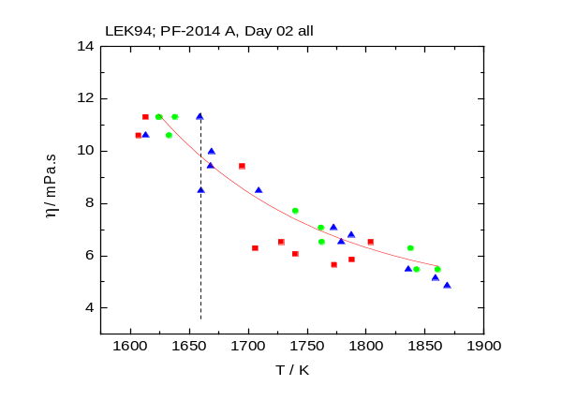
Fig.6a: Viscosity of LEK94 as a function of temperature

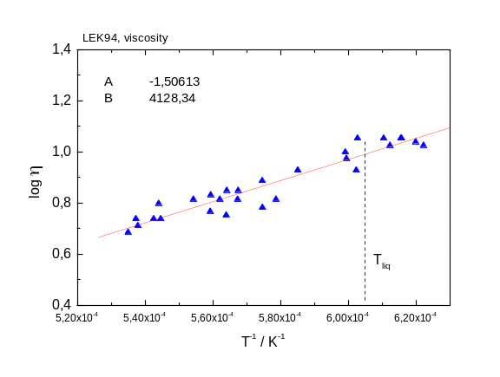
Fig.6b: Arrhenius plot of the viscosity of LEK94 as a
function of temperature. Data from all parabolas.

the Arrhenius plot can be well fitted by a linear function. For CMSX-10 the data obtained at the lowest temperatures in the undercooled liquid phase are not well represented by a linear extrapolation of the data obtained for T > T_{liq}. Thus for the linear fit shown in Figure 7a only data down to a temperature of T_{liq} - 20 K were considered.
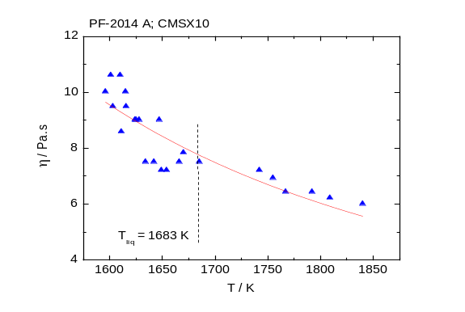
Fig.7a: Viscosity of CMSX-10 as a function of temperature

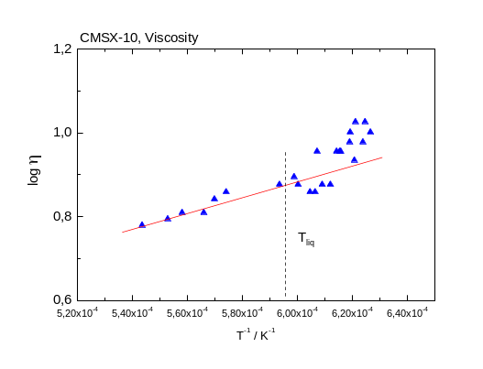
Fig.7a: Arrhenius plot of the viscosity of of CMSX-10 as a
function of temperature. All parabolas.

In Table 4 the viscosities at the liquidus temperature obtained in this work and the viscosity of CMSX-4 from Ref.11 are listed.

Tab.4: Viscosity of LEK94 and CMSX-10 at the liquidus
temperature, η (T_{liq}), and Arrhenius parameters η_{o} and ΔE_{a}.

Alloy | η (T_{liq}) / mPa | η_{o} / mPa.s | ΔE_{a} / eV atom⁻¹ | T_{liq} / K
LEK94 | 9.7 ± 1.4 |  |  | 1656
CMSX-10 | 7.7 ± 1.2 |  |  | 1683
CMSX-4 | 9.6 ± 1.2 |  |  | 1654

4. Discussion
Surface tension. At the liquidus temperature the surface tension of LEK94 and CMSX-10 agree with each other within error limits. For both alloys the surface tension as a function of temperature exhibits a linear temperature dependence with a negative temperature coefficient in the typical range −4 to −6 × 10⁻⁴ Nm⁻¹K⁻¹ as can be expected in the absence of surfactants, and of significant surface segregation. The surface tension of CMSX-10 was measured by Li et al. using the oscillating drop method in an electromagnetic levitation device under 1-g conditions to obtain a value of σ(T_{liq}) = 1.79 Nm⁻¹ about 4 % higher than the result obtained in this work. In that work the surface tension of CMSX-4 at T_{liq} was obtained as σ(T_{liq}) = 1.807 Nm⁻¹ which is in good agreement with our previously reported value of σ(T_{liq}) = 1.79 Nm⁻¹. However, in the work of Li et al. a positive temperature coefficient was observed for both CMSX-4 and CMSX-10 which always indicates the presence of a surface active element most likely oxygen. For CMSX-4 Ricci et al. reported a value σ(T_{liq}) = 1.77 N m⁻¹ a temperature coefficient of −5.6 × 10⁻⁴ Nm⁻¹K⁻¹ measured by the pinned drop method which is again in good agreement with our previous value for CMSX-4. For Rene N5 and Rene90 values of σ(T_{liq}) = 1.75 N m⁻¹ and σ(T_{liq}) = 1.85 N m⁻¹ were reported by Giuranno et al.. As such, the values of σ(T_{liq}) obtained for CMSX-10 and LEK-94 in this work are in the lower range of reported values for the Ni-based superalloys. As compared to CMSX-4, CMSX-10 has lower Cr and Co and about 2.5 at% more Al. Model calculations performed by Novakovic and Ricci showed that binary Ni-Al is the most relevant subsystem which determines the concentration dependence of the surface tension in Ni-based superalloys. As the Al content of CMSX-10 and LEK94 is similar within 1.2 at% the surface tension of both alloys can be expected to be rather similar which is indeed observed. It is however, difficult to judge if the 4% reduction of σ(T_{liq}) from CMSX-4 to CMSX-10 can be attributed solely to the increased Al concentration. According to our data the difference of the Cr and Co concentration between LEK94 and CMSX-10 is of little importance for the surface tension. This can be understood by the fact that the difference is balanced against Ni which has a rather similar surface tension of σ(T_{m}) = 1.80 ± 0.02 N m⁻¹ as given by Egry et al. as Cr and Co with σ(T_{m}) = 1.78 ± 0.02 N m⁻¹ and σ(T_{m}) = 1.93 ± 0.02 N m⁻¹, respectively, and by the dominance of the Al surface segregation in this alloy system.
Viscosity.

Acknowledgements
The parabolic flight was supported by German Space Agency DLR and by the European Space Agency ESA. Support for the project ThermoLab by the German Space Agency under contract 50WM1170 is gratefully acknowledged. Further support by the European Space Agency in the framework of its Microgravity applications support Programme for the project ThermoProp under contract xxxyyy is gratefully acknowledged. We are very grateful for the support of the Institut für Materialwissenschaft unter Weltraumbedingungen who conducted the parabolic flight measurements with the electromagnetic levitation device in particular Dr. S. Schneider and D. Heuskin with their team.

References ?T. M. Pollock and S. Tim, J of Propulsion and Power, 22 (2006) 361 – 374.
P. Caron, Superalloys 2000, eds. T. M. Pollock, R. D. Kissinger, P.R. Bowman, K. A. Green, M. McLean, S. Olson and J. Schirra, TMS (The mineral & Metals and Materrials Society) Warrendale 2000, pp. 737 – 746.
A.
Casting of Ni-based superalloys
Casting of Ni-based superalloys
Ni-based superalloys
H. Zhang, Q. Xu and b. Liu, Materials 2014, 7 , 1625-1639.
W. Wang, P. D. Lee and B. Liu, Acta Mater. 51 (2003) 2971-2987.
Ludwig thermophys prop for casting simulations
Surface tension for modelling
Em-levitation
esl
Experimetal set up
Levitation facility
Resistivity GL 1
The device was built by G. Lohöfer from DLR Cologne, Institut für Materialphysik im Weltraum, and integrated in the parabolic flight rf-generators by DLR Cologne. This device allows the measurement of the electrical resistivity. A similar device will be installed in an electromgnetic processing on board the International Space Station.
G. Lohöfer el-Widerstand induktiv
G.L. Erikson, ’A New, Third Generation, Single-Crystal, Casting Superalloy’, JOM 47 (4) (1995).
U. Glatzel, T. Mack, S. Woellmer and W. Wortmann: US-Patent US2005254991 A1 2005.
LECO analysis laboratory
Density of CMSX-10
Density of CMSX-4 and CMSX-10
Mills et al. density of CMSX-10
Surface Oscillation
Surface oscillations
Surface oscillations
Surface oscillations
Raleighy
Cummings and Blackb
I. Egry, G. Jacobs, J. Schwartz and J. Szekely, Int. J. Thermophys. 17 (1996) 1181-1189.
I. Egry, G. Lohoefer, and G. Jacobs, Phys. Rev. Lett. 75 (1995) 4043-4045.
Wunderlich NiAl
K. Higuchi spectra simulation
K. Higuchi spectra simulation
I Egry, H Giffard and S Schneider, Meas. Sci. Technol. 16 (2005) 426–431.
Viscosität oscillating drop
J.Etay and , surface oscillations.
Evaluation image analysis
Software tool
K. Higuchi, H.-J. Fecht and R. K. Wunderlich, Adv. Engn. Mat. 9 (2007) 349-354.
K. Higuchi
Effect of surfactants on temperature coefficients of surface tension.
Ozawa bumerang effect.
Surface segregation.
Z. Li, K. C. Mills, M. McLean, K.Mukai, Met. Mater. Trans. 36B (2005) 247-254.
Z. Li, K. C. Mills, M. McLean, K.Mukai, Met. Mater. Trans. 36B (2005) 247-254.
E. Ricci, D. Giuranno, R. Novakovic, T. Matsushita, S. Seetharaman, R. Brooks, L.A. Chapman and P.N. Quested, Int J. Thermophys. 28 (2007) 1304-1321.
D. Giuranno, S. Amore, R. Novakovic and E. Ricci, J. Mater. Sci. 50 (2015)3763-3771.
R. Novakovic and E. Ricci, (Calphad XXXI, Stockholm, Sweden, 2002).
I. Egry, G. Lohöfer, S. Sauerland, Int J. Thermophys 14 (1993) 573-584.

